

Syrian Virtual University

Bachelor in Information Technology

BAIT

(Renter’s Complaints Management)

Android Mobile Application

Supervisor: Dr. Mohammed Anwar Assad

By: Saleem Kassab (Saleem_87758)

01-09-2020

# Index

1 The Index 1

2 Project overview: 1

3 Project objectives 2

4 Description of system requirements: 3

1. Functional Requirements: 4

2. Non-Functional Requirements: 6

5 Software development and investigation tools 7

6 Use cases Diagram: 10

7 Use cases Description tables: 12

8 Classes Diagram 36

9 ERD and Topology Diagram 37

10 Future application developments 38

# Project overview:

Given the current situation that the world is going through from unprecedented shifts in the direction of education and digital work, in addition to the spread of the Corona epidemic, and to achieve the idea of social distancing to combat the spread of the epidemic, the idea and importance of the application of Renter’s Complaints Management came up.

As the power of the application came to automate communication between the Renter and the owner of the apartment professionally using interfaces that enable all age levels to use the application and enjoy all its features.

# Project objectives

Renter’s Complaints Management Application aims to fully coordinate between the tenant and the apartment owner, based on:

* Unifying the complaints pattern in terms of the standard form for residential apartments
* Automate routine work and rely on electronic alternatives to keep them from damage and loss.
* Speed of implementation in issuing reports and complaints within the necessary time without delay
* Archiving data within the database in the optimal manner within organized keys and sufficient spaces.
* Retrieve the archived data as required at the highest speed and filter the results according to business requirements
* Generate important reports in workflow and filter reports according to user needs
* Achieving the principle of working remotely and helping to reduce human encounter to limit the spread of the Corona epidemic
* Paper less, saving papers in order to preserve trees, environment, and eliminate traditional paperwork.

# Description of system requirements:

This application is designed to be easy to use. The design of interactive user interfaces helps to achieve this by enabling users to easily browse the Activities with a few clicks with minimal delay (almost no delay)

### Functional Requirements:

It defines the functions and capabilities that the application can successfully perform, where divided in tow levels of permissions:

#### **Admin (Apartment’s owner):**

* Create New Renter:

The Admin must enter the Renter Information:

* First Name
* Last Name
* GSM
* Building Name
* Apartment Number
* Gender
* Update Complaint’s Status:[1]

After the Renter registers a new complaint related to a problem in his apartment (we will explain it in detail later), the Admin receives the complaint and looks on it, and after resolving the problem, the Admin closes the complaint, then informing the renter using the following methods:

* Phone Call
* SMS
* WhatsApp
* Telegram
* Email
* Admin Reports:

The Renter’s reports are classified into two parts:

* Complaint’s Log:

It allows the Admin to check and review all Complaints are registered by the Renters.

* Renter’s Account Log:

It allows the Admin to check all Renter’s Accounts.

#### **Renter:**

* Register New Complaint:

It allow The Renter to add a new Complaint when he faces any problem in his Apartment to inform the Admin in it.

* Check his Complaints:

Allows the Renter to Check and follow up all his old Registered Complaints.

* Update his Information:

The Renter can check and Update all his Information.

* Check Home Safety Rules:

The Application provide the Renter with Demo (Google API) to advise the Renter with the safety rules in the home.

### Non-Functional Requirements:

The criteria that can be used to judge the performance of the application:

* Implementation and rapid response

Easy of download and use the application, two prerequisites for delivery of the application to all community users

* The possibility of expansion and development in the future
* Technical requirements:
* Minimum Android 4.0.3(IceCreamSandwich) or newer
* Internet Connection

# Software development and investigation tools

* Android Studio:

Integrated development environment (IDE) for writing application Source Code[2]

* Java Programming language:

Java is a general-purpose programming language that is class-based, object-oriented, and designed to have as few implementation dependencies as possible, to write the Application Source Code.[3]

* DB Browser (SQLite):[4]

Relational database management system (RDBMS) to Explore Application Data in virtualization mode.

* HTC Mobile with Android operating System:

For running and debugging the application using USB Connector

* NOx Android Emulator:

To run the Application on Windows Operating System

* Betternet VPN for Android Studio:

Windows application which provides a form of virtual private network services to its users through a peer-to-peer network, I used it when I need to download Libraries for Android Studio from Internet.

* Microsoft Office Visio:[5]

Diagramming and vector graphics application. It uses for drawing project design (Application topology, Database, Use Case and Class Diagrams,….) Please check all attached files.

* Microsoft Office Word:[6]

Word processor to write Project documentation.

* Lollipop Emulator:

The Android Virtual Device (AVD) is an emulator configuration that lets you model an actual device by defining hardware and software options to be emulated by the Android Emulator. It comes as an optional download when you install Android Studio.

# Use cases Diagram:

This section includes the use cases grouped under each functional requirement:

* Admin’s use cases Diagram:

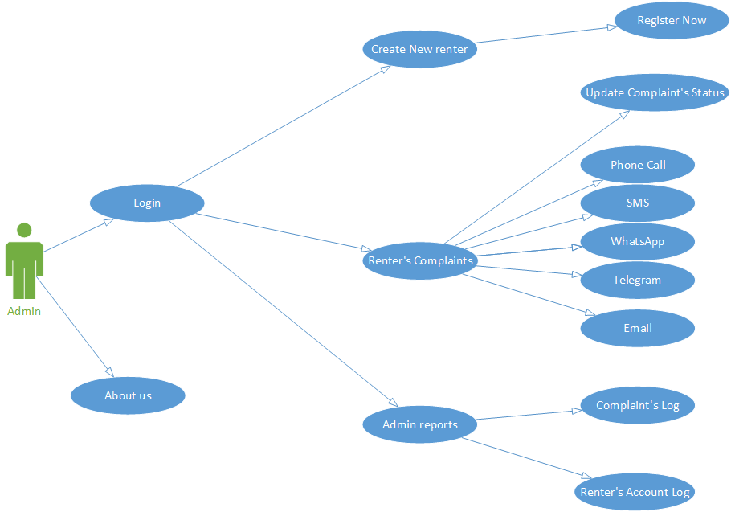

* Renter’s use cases Diagram:

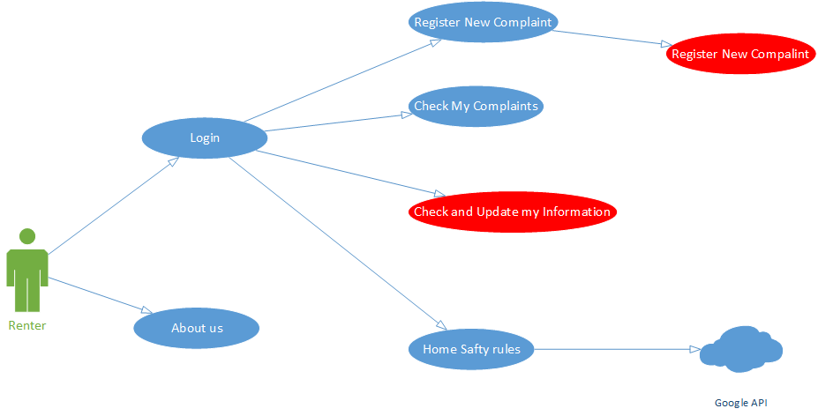

# Use cases Description tables:

|  |  |  |  |
| --- | --- | --- | --- |
| ID | UC01 | | |
| Name | Create New Renter | | |
| Brief Description | The possibility of adding, if the user has the authority of the Admin, he can create a new Renter account | | |
| Actor | Admin | | |
| Preconditions | Ensure that the entrance is valid Admin | | |
| Basic Flow |  | User | Application |
| 1 | Enter Admin information |  |
| 2 | Click Create New Renter |  |
| 3 | Fill out Create New Account Form |  |
| 4 |  | The App checks that the required fields are not left blank (First Name, Last Name, GSM, Password...) |
| 5 |  | The App verifies that the information in the fields matches the writing conditions (First Name, GSM password match…) |
| 6 | Click Create |  |
| 7 |  | Create Renter Account |
| Alternate Flow | If the system finds that the entered Renter’s GSM is duplicate, then the process will not be completed and the error messages appear to the Admin. | | |
| Post Condition | If the operation is completed successfully, the information is added in the database on the basis of a new Renter and a message appears that the operation  was successful | | |

|  |  |  |  |
| --- | --- | --- | --- |
| ID | UC02 | | |
| Name | Update Complaint's Status | | |
| Brief Description | The Admin modifies Renter’s Complaint Status, as the system checks his validity and the possibility of modification, and if his authority is Admin, he can update all Renter’s Complaints. | | |
| Actor | Admin | | |
| Preconditions | Ensure that the entrance is Admin | | |
| Basic Flow |  | User | Application |
| 1 | Click renter’s Complaints |  |
| 2 | Fill out required Fields |  |
| 3 |  | The App checks that the required fields are not left blank (Complaint Number, Admin Comment) |
| 4 | Click Update Complaint Status |  |
| 5 |  | Update and Store the New  Complaint’s Status |
| Alternate Flow | The App found that the entered information is incomplete or incorrect, Then the operation does not complete and error messages appear that appear in place of the error entered in the application. | | |
| Post Condition | If the operation is completed successfully, the information is updated in the database and Show a Success alerting notification[7] for the Admin | | |

|  |  |  |  |
| --- | --- | --- | --- |
| ID | UC03 | | |
| Name | Phone Call[8] | | |
| Brief Description | The Admin can alarm the Renter when he follow up (Check and update) his Complaint, as the system checks his validity and the possibility of modification, and if his authority is Admin, he can make a phone call with the renter to inform him with the New Complaint’s Status. | | |
| Actor | Admin | | |
| Preconditions | Ensure that the entrance is valid Admin | | |
| Basic Flow |  | User | Application |
| 1 | Click Renter’s Complaints |  |
| 2 | Fill out required Fields |  |
| 3 |  | The App checks that the required fields are not left blank (Complaint Number, Admin Comment) |
| 4 | Click Update Complaint's Status |  |
| 5 |  | Update and Store the New Complaint’s Status (Admin Comment) |
| 6 | Click Phone Call |  |
| 7 |  | The App Makes a new External Integration with Call Application to make a new call with the Renter |
| 8 | Call The Renter |  |
| Alternate Flow | The App found that the entered information is incomplete or incorrect, Then the operation does not complete and error messages appear that appear in place of the error entered in the application. | | |
| Post Condition | If the operation is completed successfully, The Admin can make a new Phone call with Renter | | |

|  |  |  |  |
| --- | --- | --- | --- |
| ID | UC04 | | |
| Name | SMS[9] | | |
| Brief Description | The Admin can alarm the Renter when he follow up (Check and update) his Complaint, as the system checks his validity and the possibility of modification, and if his authority is Admin, he can send SMS Message to the renter to inform him with the New Complaint’s Status. | | |
| Actor | Admin | | |
| Preconditions | Ensure that the entrance is valid Admin | | |
| Basic Flow |  | User | Application |
| 1 | Click Renter’s Complaints |  |
| 2 | Fill out required Fields |  |
| 3 |  | The App checks that the required fields are not left blank (Complaint Number, Admin Comment) |
| 4 | Click Update Complaint's Status |  |
| 5 |  | Update and Store the New Complaint’s Status (Admin Comment) |
| 6 | Click SMS |  |
| 7 |  | The App Makes a new External Integration with SMS messages Application to send a new SMS to the Renter |
| 8 | Send SMS |  |
| Alternate Flow | The App found that the entered information is incomplete or incorrect, Then the operation does not complete and error messages appear that appear in place of the error entered in the application. | | |
| Post Condition | If the operation is completed successfully, The Admin can send a new message to the Renter | | |

|  |  |  |  |
| --- | --- | --- | --- |
| ID | UC05 | | |
| Name | WhatsApp[10] | | |
| Brief Description | The Admin can alarm the Renter when he follow up (Check and update) his Complaint, as the system checks his validity and the possibility of modification, and if his authority is Admin, he can send WhatsApp Message to the renter to inform him with the New Complaint’s Status. | | |
| Actor | Admin | | |
| Preconditions | Ensure that the entrance is valid Admin | | |
| Basic Flow |  | User | Application |
| 1 | Click Renter’s Complaints |  |
| 2 | Fill out required Fields |  |
| 3 |  | The App checks that the required fields are not left blank (Complaint Number, Admin Comment) |
| 4 | Click Update Complaint's Status |  |
| 5 |  | Update and Store the New Complaint’s Status (Admin Comment) |
| 6 | Click WhatsApp |  |
| 7 |  | The App Makes a new External Integration with WhatsApp Application to send a new WhatsApp message to the Renter |
| 8 | Send WhatsApp message |  |
| Alternate Flow | The App found that the entered information is incomplete or incorrect, Then the operation does not complete and error messages appear that appear in place of the error entered in the application. | | |
| Post Condition | If the operation is completed successfully, The Admin can send a new WhatsApp message to the Renter | | |

|  |  |  |  |
| --- | --- | --- | --- |
| ID | UC06 | | |
| Name | Telegram[11] | | |
| Brief Description | The Admin can alarm the Renter when he follow up (Check and update) his Complaint, as the system checks his validity and the possibility of modification, and if his authority is Admin, he can send Telegram Message to the renter to inform him with the New Complaint’s Status. | | |
| Actor | Admin | | |
| Preconditions | Ensure that the entrance is valid Admin | | |
| Basic Flow |  | User | Application |
| 1 | Click Renter’s Complaints |  |
| 2 | Fill out required Fields |  |
| 3 |  | The App checks that the required fields are not left blank (Complaint Number, Admin Comment) |
| 4 | Click Update Complaint's Status |  |
| 5 |  | Update and Store the New Complaint’s Status (Admin Comment) |
| 6 | Click Telegram |  |
| 7 |  | The App Makes a new External Integration with Telegram Application to send a new WhatsApp message to the Renter |
| 8 | Send Telegram message |  |
| Alternate Flow | The App found that the entered information is incomplete or incorrect, Then the operation does not complete and error messages appear that appear in place of the error entered in the application. | | |
| Post Condition | If the operation is completed successfully, The Admin can send a new Telegram message to the Renter | | |

|  |  |  |  |
| --- | --- | --- | --- |
| ID | UC07 | | |
| Name | Email[12] | | |
| Brief Description | The Admin can alarm the Renter when he follow up (Check and update) his Complaint, as the system checks his validity and the possibility of modification, and if his authority is Admin, he can send Email Message to the renter to inform him with the New Complaint’s Status. | | |
| Actor | Admin | | |
| Preconditions | Ensure that the entrance is valid Admin | | |
| Basic Flow |  | User | Application |
| 1 | Click Renter’s Complaints |  |
| 2 | Fill out required Fields |  |
| 3 |  | The App checks that the required fields are not left blank (Complaint Number, Admin Comment) |
| 4 | Click Update Complaint's Status |  |
| 5 |  | Update and Store the New Complaint’s Status (Admin Comment) |
| 6 | Click Email |  |
| 7 |  | The App Makes a new External Integration with WhatsApp Application to send a new Email to the Renter |
| 8 | Send Email |  |
| Alternate Flow | The App found that the entered information is incomplete or incorrect, Then the operation does not complete and error messages appear that appear in place of the error entered in the application. | | |
| Post Condition | If the operation is completed successfully, The Admin can send a new Email to the Renter | | |

|  |  |  |  |
| --- | --- | --- | --- |
| ID | UC08 | | |
| Name | Complaint's Log[13] | | |
| Brief Description | The Admin can reviews the Renter’s Complaints, where the system checks its validity and the ability to display, and if he has the authority of the Admin, he can Check all Renter’s Complaints. | | |
| Actor | Admin | | |
| Preconditions | Ensure that the entrance is valid Admin | | |
| Basic Flow |  | User | Application |
| 1 | Click Admin Reports |  |
| 2 | Click Complaint’s Log |  |
| 3 |  | Checking for Renter’s Complaints. |
| 4 |  | Display Renter’s Complaints on the screen |
| Alternate Flow | ---------- | | |
| Post Condition | View all Renter’s registered Complaints orderly | | |

|  |  |  |  |
| --- | --- | --- | --- |
| ID | UC09 | | |
| Name | Renter's Accounts Log | | |
| Brief Description | The Admin can reviews all renter’s accounts, where the system checks its validity and the ability to display, and if he has the authority of the Admin, he can check all Renter’s accounts details. | | |
| Actor | Admin | | |
| Preconditions | Ensure that the entrance is valid Admin | | |
| Basic Flow |  | User | Application |
| 1 | Click Admin Reports |  |
| 2 | Click Renter's Accounts Log |  |
| 3 |  | Checking for Renter’s accounts. |
| 4 |  | Display Renter’s accounts on the screen |
| Alternate Flow | ---------- | | |
| Post Condition | View all Renter’s accounts orderly | | |

|  |  |  |  |
| --- | --- | --- | --- |
| ID | UC10 | | |
| Name | Register New Complaint | | |
| Brief Description | The possibility of Add a new Complaint, if he has the authority of the Renter, he can create a new Complaint with an open status (New Complaint without Admin Action) | | |
| Actor | Admin | | |
| Preconditions | Ensure that the entrance is valid Renter | | |
| Basic Flow |  | User | Application |
| 1 | Enter Renter’s information |  |
| 2 | Click Login |  |
| 3 | Click Register New Complaint |  |
| 4 | Fill out Add New Complaint Form |  |
| 5 |  | The App checks that the required fields are not left blank (Building Name, Apartment Number, Complaint Description) |
| 6 | Click Register New Complaint |  |
| 7 |  | Add New Complaint with open status |
| Alternate Flow | If the system finds that the entered data is incorrect, then the process will not be completed and error messages appear to the Renter. | | |
| Post Condition | If the operation is completed successfully, the information is added in the database and a message appears that the operation  was successful | | |

|  |  |  |  |
| --- | --- | --- | --- |
| ID | UC11 | | |
| Name | Check my Complaints | | |
| Brief Description | The Renter can reviews all his Complaints, where the system checks its validity and the ability to display, and if he has the authority of the Renter, he can check all registered complaint. | | |
| Actor | Admin | | |
| Preconditions | Ensure that the entrance is valid Admin | | |
| Basic Flow |  | User | Application |
| 1 | Click Check my Complaints |  |
| 2 |  | Checking for Renter’s complaints |
| 3 |  | Display Renter’s complaints on the screen |
| Alternate Flow | ---------- | | |
| Post Condition | View all Renter’s complaints orderly | | |

|  |  |  |  |
| --- | --- | --- | --- |
| ID | UC12 | | |
| Name | Check and Update my Information | | |
| Brief Description | The Renter can update his personal information, as the system checks his validity and the possibility of modification, and if his authority is a Renter, he is can only update his information. | | |
| Actor | Renter | | |
| Preconditions | Ensure that the entrance is valid Admin | | |
| Basic Flow |  | User | Application |
| 1 | Click Check and update my Information |  |
| 2 | Fill out required fields |  |
| 3 |  | The App checks that the required fields are not left blank (First Name, Last Name, GSM, New Password) |
| 4 |  | The App verifies that the information in the fields matches the writing conditions (First Name, Last Name, GSM ...) |
| 5 | Click For Update |  |
| 6 |  | Update and Store the New Information |
| Alternate Flow | The App found that the entered information is incomplete or incorrect, Then the operation does not complete and error messages appear that appear in place of the error entered in the application. | | |
| Post Condition | If the operation is completed successfully, the information is added in the database and Show a Success alerting notification[14] for the Renter | | |

|  |  |  |  |
| --- | --- | --- | --- |
| ID | UC13 | | |
| Name | Home Safety Rules[15] | | |
| Brief Description | The Renter can check Home Safety Rules, as the system checks his validity and the possibility of modification, and if his authority is Renter. | | |
| Actor | Renter | | |
| Preconditions | Ensure that the entrance is valid Renter | | |
| Basic Flow |  | User | Application |
| 1 | Click Home Safety Rules |  |
| 2 |  | The App checks that the Internet connection |
| 3 |  | View Home Safety Rules Demo |
| Alternate Flow | The App found that the Internet Connection is not available, Then the operation does not complete and error messages appear that “No Internet Connection”. | | |
| Post Condition | If the operation is completed successfully, the Renter can check the home safety rules conditions | | |

|  |  |  |  |
| --- | --- | --- | --- |
| ID | UC14 | | |
| Name | About | | |
| Brief Description | Any Application User can check About application Details. | | |
| Actor | Admin and Renter | | |
| Preconditions | Ensure that the entrance is valid Admin or Renter | | |
| Basic Flow |  | User | Application |
| 1 | Click About |  |
| 2 |  | The Application view application details |
| Alternate Flow | --------- | | |
| Post Condition | ------------- | | |

# Classes Diagram

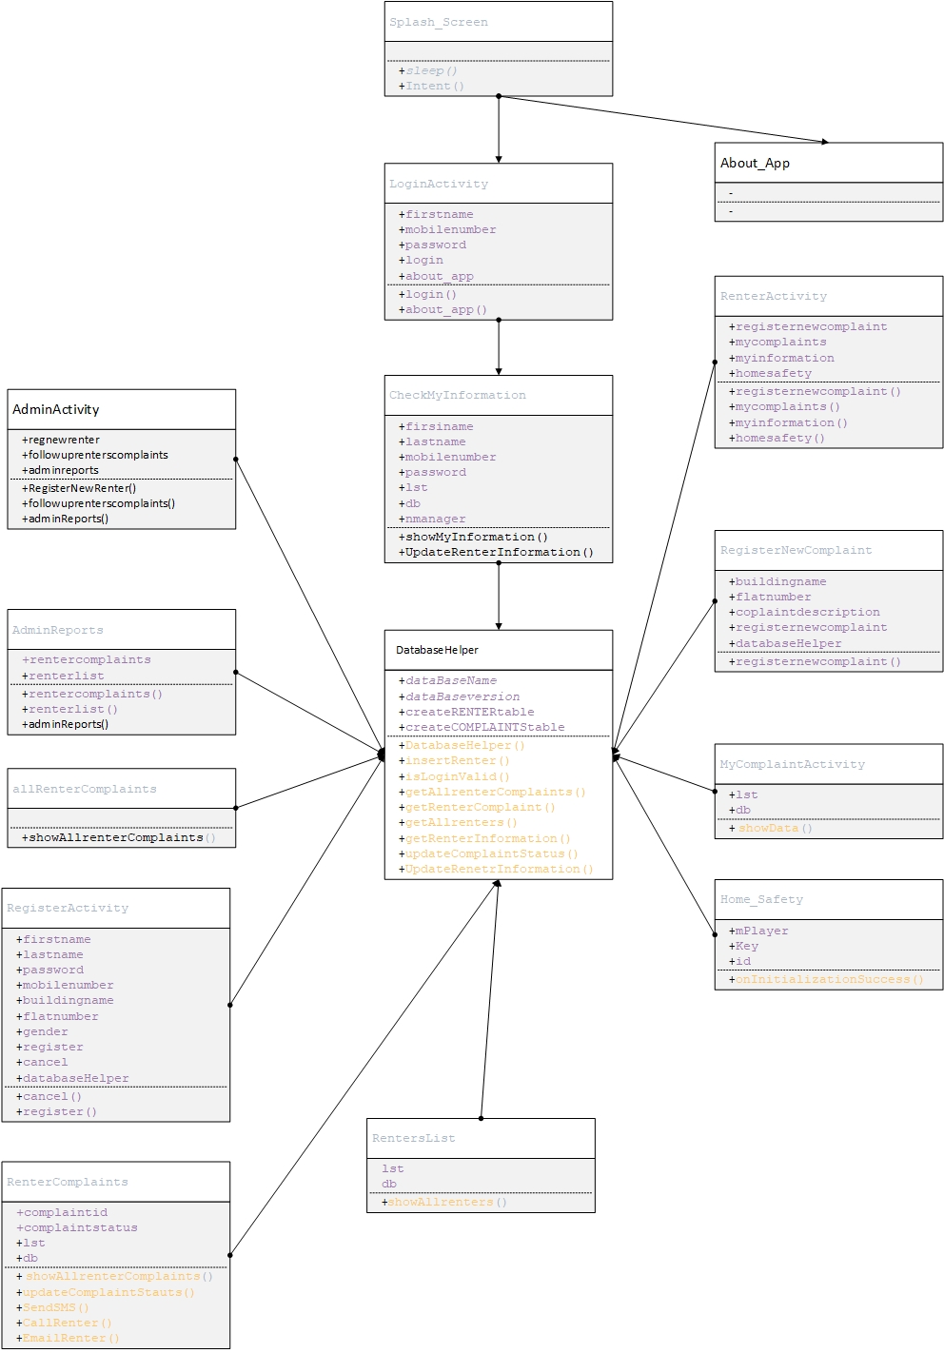

Please check Classes Diagram (Visio) in attached file clearly more

# ERD and Topology Diagram

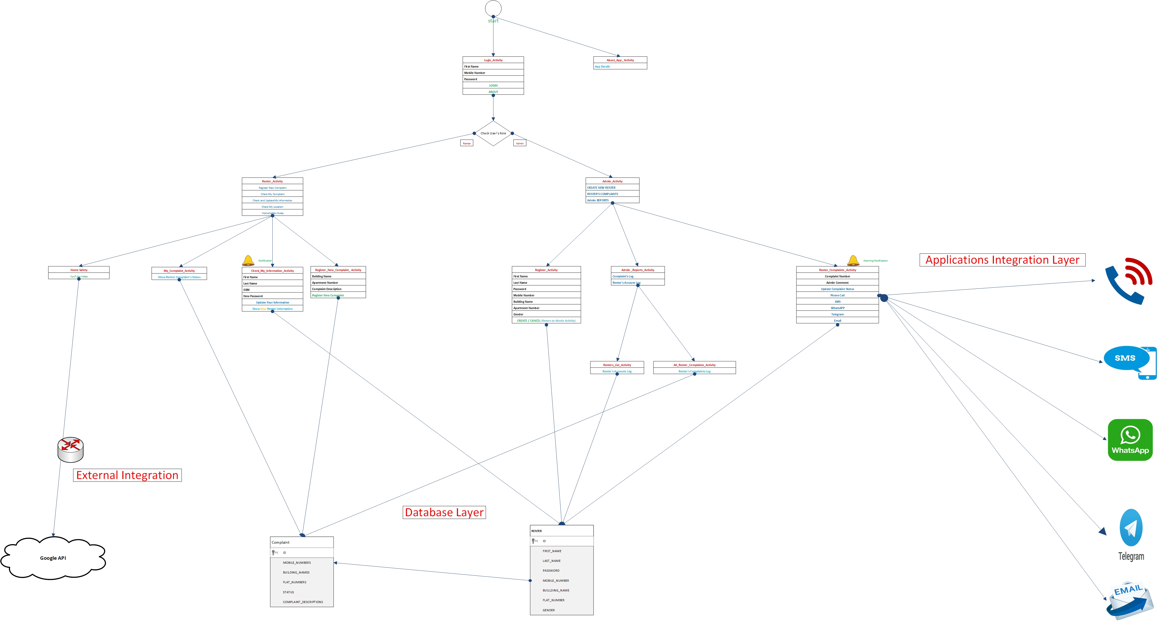

Please check Topology and ERD file in attached file clearly more

# Future application developments

The application can be developed and its uses integrated by linking it with the equipment and robots of artificial intelligence and the Internet of things through the use of specific robots to receive the complaint submitted by the application directly and the robot to address the problem without user intervention

Let us check our Application

All thanks and appreciation

1. <https://www.youtube.com/watch?v=j7IIoeABwhE&list=PL7VN7OBi_bOO0I3nYn7VqrMws0wLrQtdx&index=89>
2. <https://en.wikipedia.org/wiki/Android_Studio>
3. <https://en.wikipedia.org/wiki/Java_(programming_language)>
4. <https://www.youtube.com/watch?v=_6p7BqjNANQ>
5. <https://www.microsoft.com/en-us/microsoft-365/visio/flowchart-software>
6. <https://www.microsoft.com/en-us/microsoft-365/word>
7. <https://developer.android.com/guide/topics/ui/notifiers/notifications>
8. <https://www.youtube.com/watch?v=V2uDq4Gm53w>
9. <https://www.youtube.com/watch?v=BTHEFRZ1_CI>
10. <https://www.youtube.com/watch?v=V2uDq4Gm53w>
11. <https://www.youtube.com/watch?v=V2uDq4Gm53w>
12. <https://www.youtube.com/watch?v=V2uDq4Gm53w>
13. <https://www.youtube.com/watch?v=2xXW2j4rUZs&list=PL7VN7OBi_bOO0I3nYn7VqrMws0wLrQtdx&index=88>.
14. <https://developer.android.com/guide/topics/ui/notifiers/notifications>
15. <https://www.youtube.com/watch?v=W4hTJybfU7s>